International Conference of Aerospace Sciences
under the patronage of the
Ministry of Research and Innovation
 |  | 
 | 
INCAS ― National Institute for Aerospace Research “Elie Carafoli”
(Under the aegis of The Romanian Academy)

International Conference of Aerospace Sciences
“AEROSPATIAL 2018”
25 - 26 October 2018, Bucharest, Romania

Please download this Form from http://aerospatial-2018.incas.ro/registration.html and please return to e-mail: nebancea.elena@incas.ro

Authors 1:*
Family Name:*___________________________________________ First Name:*______________________________
Title:* Prof. Dr. Mr. Ms. Other: ___________________ Position:________________________________
Organization: * ___________________________________________________________________________________
Address: *_______________________________________________________________________________________
City: *______________________________ Post/Zip Code: ___________________ Country:*_____________________
Telephone: *____________________________ Fax:*__________________ E-mail:* ____________________________
Authors 2
Family Name:*___________________________________________ First Name:*______________________________
Title:* Prof. Dr. Mr. Ms. Other: ___________________ Position:________________________________
Organization: * ___________________________________________________________________________________
Address: *_______________________________________________________________________________________
City: *______________________________ Post/Zip Code: ____________________ Country:*______________________
Telephone: *____________________________ Fax:*__________________ E-mail:* ____________________________
Authors 3:
Family Name:*___________________________________________ First Name:*______________________________
Title:* Prof. Dr. Mr. Ms. Other: ___________________ Position:________________________________
Organization: * ___________________________________________________________________________________
Address: *_______________________________________________________________________________________
City: *______________________________ Post/Zip Code: ___________________ Country:*_____________________
Telephone: *____________________________ Fax:*__________________ E-mail:* ____________________________
Authors 4:
Family Name:*___________________________________________ First Name:*______________________________
Title:* Prof. Dr. Mr. Ms. Other: ___________________ Position:________________________________
Organization: * ___________________________________________________________________________________
Address: *_______________________________________________________________________________________
City: *______________________________ Post/Zip Code: ___________________ Country:*_____________________
Telephone: *____________________________ Fax:*__________________ E-mail:* ____________________________
Authors 5:
Family Name:*___________________________________________ First Name:*______________________________
Title:* Prof. Dr. Mr. Ms. Other: ___________________ Position:________________________________
Organization: * ___________________________________________________________________________________
Address: *_______________________________________________________________________________________
City: *______________________________ Post/Zip Code: ___________________ Country:*_____________________
Telephone: *____________________________ Fax:*__________________ E-mail:* ____________________________

The main topics of the “AEROSPATIAL 2018” Conference are the following (additional topics could be included upon request).
Please select one from the following Conference section (1 – 8) and Events associated:
1. Aerodynamics;
2. Flight Mechanics;
3. Astronautics and Astrophysics;
4. Materials and Structures;
5. Systems, Subsystems and Control in Aeronautics;
6. Experimental Investigations in Aerospace Sciences;
7. ATS and full Automation ATM;
8. Management in Aerospace Activities.

Events associated with of the conference
“100 Years of Aviation in Romania” (1918-2018), together with the Romanian Academy, 24 October, 2018
The “Nicolae Tipei” Prize Award Ceremony
The “Gheorghe Vasilca” Prize Award Ceremony
Celebrating Excellence
Visits in the “top laboratories” of the INCAS – Bucharest.

Title of the paper: *

----------------------------------------------------------------------------------------------------------------------

ABSTRACT : (max. 200 words):*

----------------------------------------------------------------------------------------------------------------------

DEADLINES:
- Abstracts submission: 30.08.2018
- Acceptance confirmation: 07.09.2018
- Registration: 10.08.2018
- Full papers submission for Proceedings:
- Printed version: 15.08.2018 – 28.09.2018

REGISTRATION
- The Abstracts shall be written in English (the abstract shall not exceed 200 words, drawn up in Word, Times New Roman, 10), before 30.08.2018. The participants in the conference are asked to send the paper title and abstract to the following address: nebancea.elena@incas.ro.
- Those who receive confirmation of acceptance are asked to complete the Registration form (see website http://aerospatial-2018.incas.ro) and to send it to the address nebancea.elena@incas.ro until: 10.08.2018

PARTICIPATION FEE
- The fee for participation with article: 200 LEI
- The participation with article for students is free.
- The participation fee can be paid at the INCAS headquarters in the very day of the conference: 200 LEI or by bank transfer, mentioning for: “AEROSPATIAL 2018” (see below).
Others fees:
- The authors who pay the above mentioned fee can participate in the conference with a single work.
- For the second paper presented in the conference by the same author (as first author), the fee is 50 LEI.
- The fee for participation with article also includes all the materials related to the conference (the Program, the Book of Abstracts), coffee breaks, lunch and Gala Dinner.
PAYMENT
For the Romanian authors the payment should be done in LEI for the foreign participants, please make the payment in Euro / Dolar.
The three accounts are:
Cod IBAN RON: RO 86 RNCB 0290101344950001
Cod IBAN EUR: RO 59 RNCB 0290101344950002
Cod IBAN USD: RO 32 RNCB 0290101344950003
The address of the BCR Bank:
Blvd Iuliu Maniu no.190-192, bl.C1, area 6, Bucharest, Romania
SWIFT/ BIC CODE: RNCBROBU
VAT: RO434670

PROCEEDINGS
The papers that are accepted will be included in a volume (Printed Conference Proceedings). The papers shall be sent to the nebancea.elena@incas.ro, in electronic form (Word and PDF format).
The page setup shall be as follows: top-2 cm, bottom-2 cm, left-2 cm, right-2 cm, A4 format. The papers should not exceed 12 pages, font Times New Roman 11, single spacing, without diacritics, without page numbering.
The papers accepted for the conference "AEROSPATIAL 2018" shall be written in English.
The Conference printed version will include only the items presented at the conference and having a favourable review.
Note: The Volume of scientific papers "AEROSPATIAL 2018" can be purchased by those interested, by placing an order at a price that will be communicated in due time.
We inform you that for Proceedings the following codes were obtained from the ISSN National Center: (Print) ISSN 2067-8614, ISSN-L 2067-8614
- Selected papers will be published in of the scientific journal INCAS BULLETIN: http://bulletin.incas.ro, (Print) ISSN 2066-8201, (Online) ISSN 2247-4528, ISSN-L 2066-8201, DOI: 10.13111/2066-8201
- Deadline: 25.10.2018
- INCAS BULLETIN is “Open Access” (OA).
- INCAS BULLETIN is indexed in International Databases (BDI): Directory of Open Access Journals (DOAJ), Index Copernicus™ - Journals Master List, Crossref, ProQuest, EBSCOhost, Academic Journals Database, SCIPIO - Romanian Editorial Platform, DRJI, China National Knowledge Infrastructure (CNKI-SCHOLAR), SHERPA/ROMEO, WorldCat, J-Gate.

SPONSORS
We invite all the Trading Companies or Aeronautical Societies interested in cooperating on the Conference organizing and carrying-on (in different ways: dissemination, proposals, scientific and technical contributions and also logistic and financial support) to let us know by addressing the organizing committee up to 14.10.2018 to be included on the collaborators list which will be mentioned in the Second Call.
The sponsors will conclude a sponsorship agreement specific to the conference.
LOCATION
The International Conference of Aerospace Sciences “AEROSPATIAL 2018”, will be held on 25 – 26 October 2018 in Bucharest at the INCAS – National Institute of Aerospace Research “Elie Carafoli”, B-dul Iuliu Maniu no. 220, sector 6.
The INCAS is located in the Militari district of Bucharest (in the west part of the city), near by the subway station "Pacii". One can reach INCAS also using trolleybuses route 61, route 62 and buses route 137, route 138, route 178 and route 236 Valea Cascadelor Station.
For more informations see Route map of Bucharest.

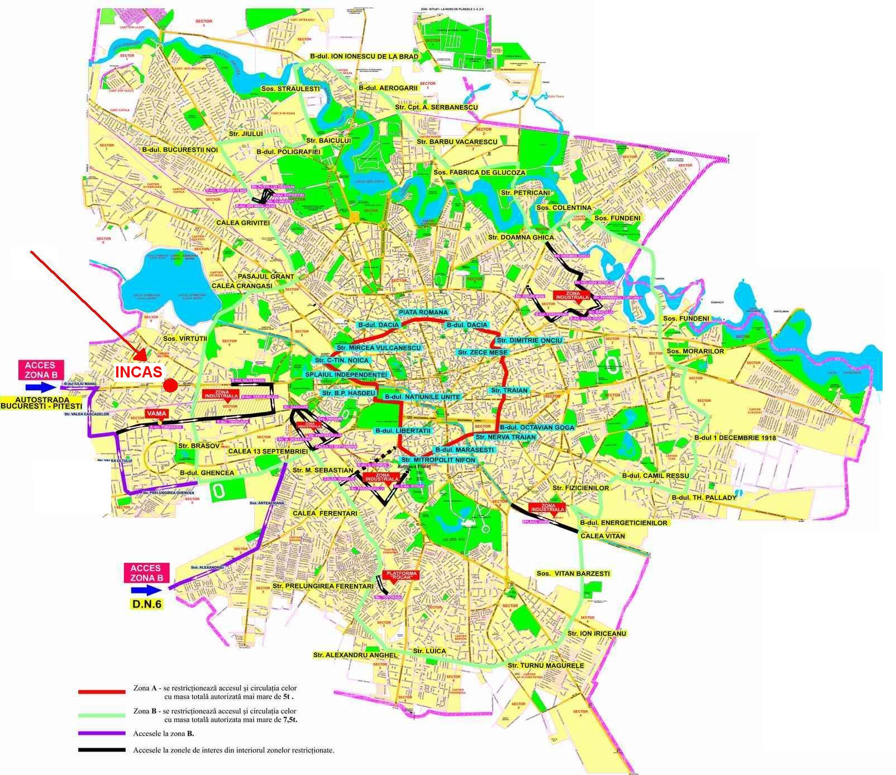

From the city center to INCAS the most convenient transportation is by metro. INCAS is located at the exit of PACII station (see map – red line).

A ticket for two trips with the metro costs 5 RON ≅ 1.1 Euro
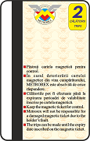
Also, you can use a taxi (estimated price is 10 Euro).

Bucharest Metro Map

